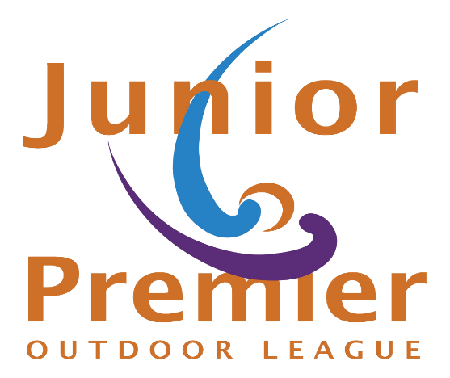
JPOL Combined - ENTRY FORM

April 18th, 2026 – June 7th, 2026
DIVISION: (Circle)
- U16 Combined

- U19 Combined

- U14 Combined

Team Name: ______________________________

Team Colors: ______________________________

Team Contact: _____________________________
Address: __________________________________________________

__________________________________________________

Phone Number: __________________________________

E-mail: _________________________________________
Please submit Entry Form with Non-Refundable deposit of $200.00 per team by February 15, payable to:

Junior Premier Hockey
PO Box 1229
North Baldwin, NY 11510

VENMO Account: @juniorPremierHockey

Remaining Balance of $2,200 is due on or before March 1!!

